MS Communicator and Live Meeting 2007
Training Guide
Communicator and Live Meeting work together to provide a robust communications platform. The programs replace Communicator 2005 and NetMeeting. This class covers both applications.

Communicator 2007
If you are in the office, you will be signed in to Communicator automatically when you start your laptop. If you are out of the office, connect to the Internet and Cisco VPN, the open Communicator. There are two ways to launch Communicator 2007:

StartAll ProgramsMS Office Communicator 2007

Double-click the new icon in the system tray in the lower right

sign-in name is your e-mail address – no password needed
If you are prompted for a password there is a problem – contact the Help Desk.

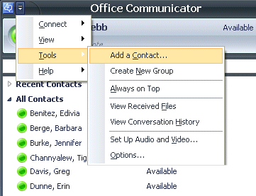
Chat

Chat with American Capital staff
There are two ways to chat with an American Capital person - - add them as contact, or just type an e-mail address.

Add contacts
Contacts are added in the same way as Communicator 2005.

Type an e-mail address
You don’t have to add a person as a contact to chat with them. Just type in an e-mail address to start chatting.
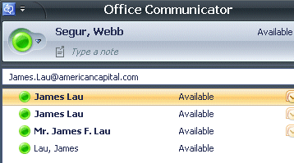

You may send an IM to an Outlook distribution list
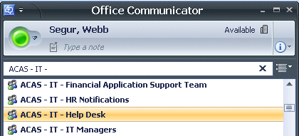
You may start a group chat session by typing an Outlook Distribution list name in the Communicator header box.
Type part of the list name, then choose it to start chatting with a group.

Chat with people outside of American Capital
Yahoo Messenger and AOL messenger are supported; MSN Live is not supported yet.

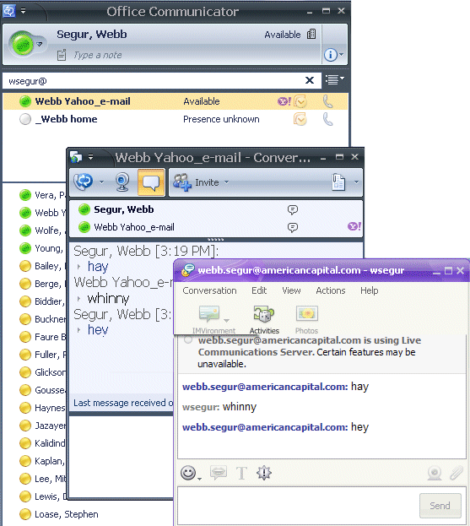
Other person must use client IM software, not browser version.
For example, a person needs to install Yahoo Messenger if you want to chat with them from your Communicator program.

Features

Add a note
Type a note under your name that others will see when they mouse over your name in their contact list.

Change your location
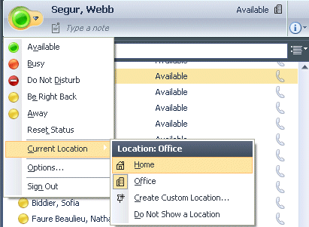
Click the list arrow by the presence button to display a different location.
New location displayed here

Add groups
You may add groups to organize your contacts.

Right-click the ‘All Contacts’ group label

Select Create New Group

Type a name for the new group

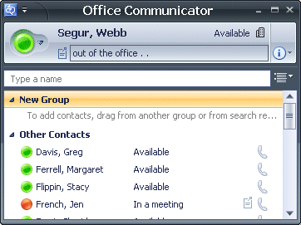
Drag contacts into the group
Drag contacts into new group

Set access levels
Five levels are available: Personal, Team, Company, Public and Blocked. To change a contact’s access level, right-click and select Change Level of Access.
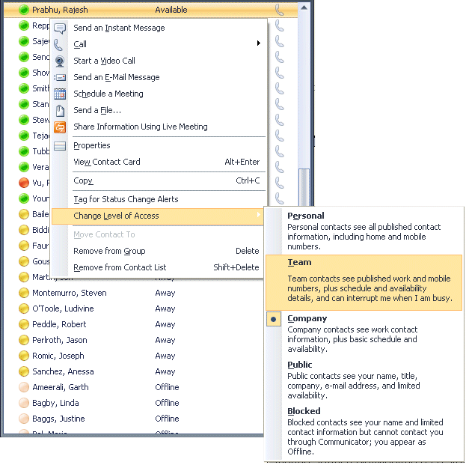

Set options
Click the list arrow by the title bar icon and select ToolsOptions. Set options as desired.
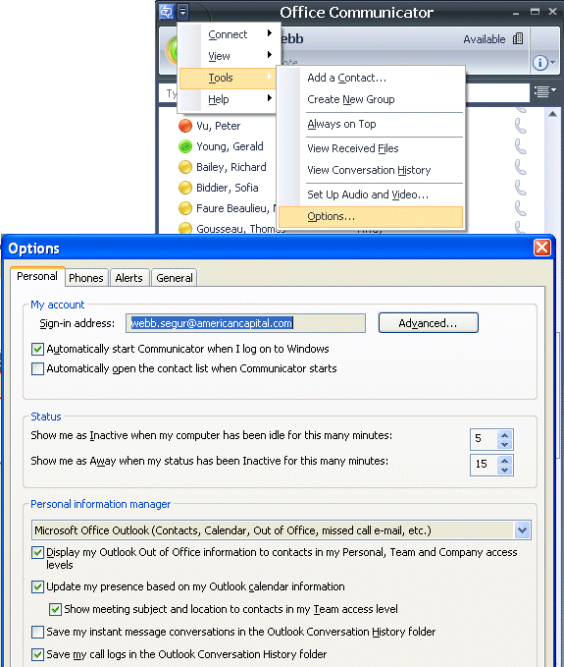

Using Help, tour, online training
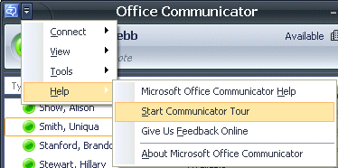
A standard MS Help file is available, as is a tour of Communicator 2007. Choose them from the list arrow in the title bar.

Online training for Communicator is also available at this address:
http://office.microsoft.com/en-us/training/CR102533351033.aspx

Live Meeting
Live Meeting is your new electronic meeting tool. There are three ways to launch Live Meeting:

StartAll ProgramsMS OFFice Live Meeting 2007 MS OFFice Live Meeting 2007

In outlooknew toolbar

In Communicatorright-click on the person’s name and choose ‘share information using Live Meeting’

Start or schedule a Live Meeting

Test your connection
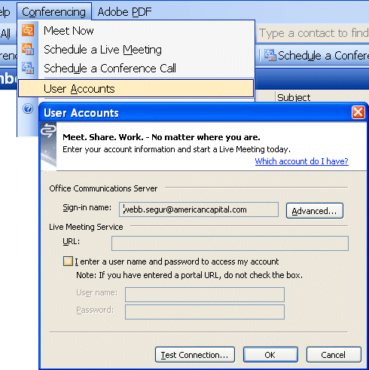
Confirm your Live Meeting connection before using it. From Outlook, select ConferencingUser AccountsTest Connection.

start a meeting from Communicator
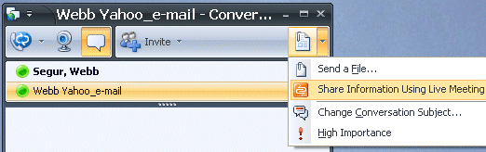
After starting chat, launch Live Meeting from the menu.

Start a meeting from Outlook

Meet now
Click the Meet Now button in the Outlook toolbar.
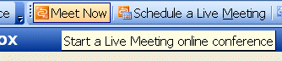

The Live Meeting window opens. Invite others to the meeting by selecting AttendeesInviteBy E-mail.
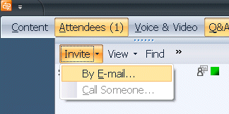

An e-mail window will open. Address and send the e-mail to the desired participants. They will click the link in the e-mail to join the meeting.

Schedule a meeting
Click the Schedule a Live Meeting button in the Outlook toolbar. A meeting form opens.

If desired, attendees can be designated as meeting presenters.

Send the meeting invitation. Participants will click a link to join your meeting.
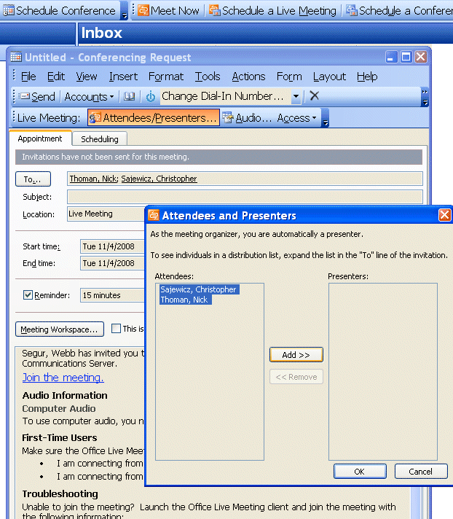

Features
Use these tools from the Live Meeting window.

Share your desktop
From the Live Meeting menu, choose ContentShare and select Share a Program or share Your Desktop.
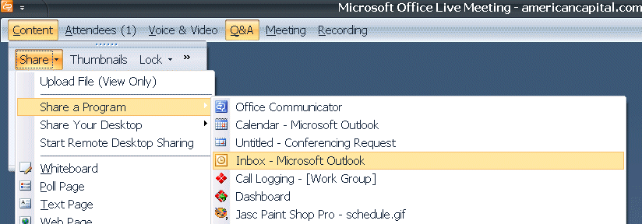

Give control to others
Click the Give Control button in the toolbar, then choose a person from the list to give him/her control of keyboard and mouse.
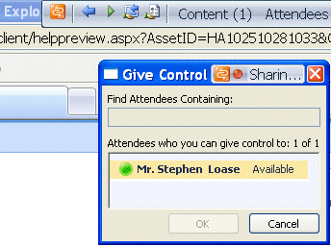

Set up questions and polling
To create a poll,

Select ContentSharePoll page

Type the poll questions and answers, click OK

Attendees will se a poll page and cast their vote by clicking a radio button

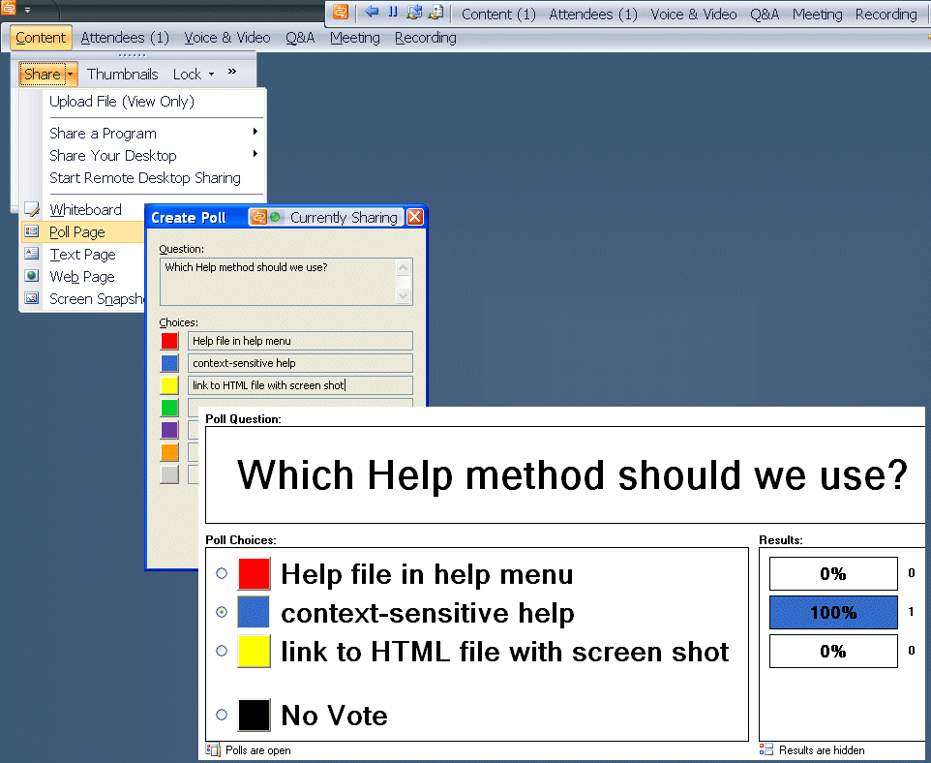
attendees will
see this

Park files as meeting handouts that can be retrieved by attendees

Click the Handouts icon in the toolbar.
A dialog box opens.

Click Upload

Browse and select files.

Click Open
The files are uploaded.
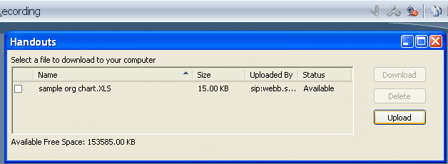

Attendees retrieve files by clicking the Handouts icon, selecting a file, then clicking the Download button.

Record a meeting

Click the Record button in the toolbar to record the meeting.

The Live Meeting Recording Manager icon in the tray will show an alert when the recording is ready. Double-click to open the recording manager.

Double-click the row in Recording Manager to play the recording.
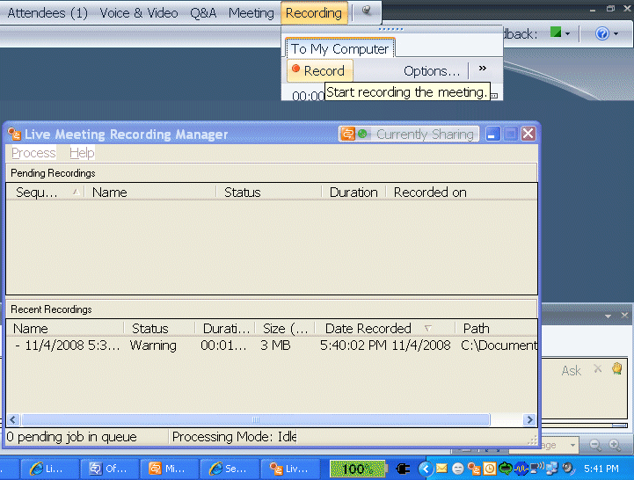
3
2
1

