

**SalesLogix CRM**

**Investment Closing Summary “ICS” Overview**

**CONTENTS**

A. before you begin . . . 4

1. View required fields list 4

B. create the ICS page 4

C. ICs record layout 4

D. Sequence for competing the data tabs 5

E. add necessary detail 6

1. Investment Setup Tab 6

2. Sub-tranches Tab 7

3. Fees Tab 7

4. Expenses Tab 7

5. Financial Covenants tab 7

6. Company Financials and Compensation Tab 8

7. Capital Considerations Tab 8

8. Warrants Tab 8

9. Sources and Uses Tab 8

10. Net Proceeds Tab 9

11. File Attachments Tab 10

12. ICS Meeting Attandance and Deal Team Members Tabs 10

13. Notes and History Tab 10

F. Print and review the ICS 10

G. submit the ICS 11

H. The deal is closed! 11

The Investment Closing Summary, or ICS, is the key and final SalesLogix record which is completed prior to funding the transaction.

Before creating the ICS, the deal team confirms that required fields in the opportunity record have been filled in. The team prepares the ICS record, reviews it, and submits it for approval to the Office of the COO. While awaiting approval, the ICS record is locked. Often changes are needed, in which case the ICS record is unlocked, the deal team edits the ICS , and submits it again for approval. This process repeats until the Office of the COO signs off.

Final approval and closing the transaction in SalesLogix is done in conjunction with the Treasury department.

The ICS requires a lot of detail; deal teams should allow plenty of time before the closing date to prepare, submit and finalize an ICS. At minimum, the ICS must be completed 48 hours before funding.

Note that in general, the source of all information provided in the ICS should be negotiated legal documents.

## before you begin . . .

Several fields in the SalesLogix opportunity records are required before the system permits an ICS record to be created.

### View required fields list

Click the blue Help button by the View ICS button in the upper right of the opportunity record to see the required fields.



The Target Company, Code Name, Final IC Circulated date, Estimated Closing date, and Term Sheet signed date fields must be completed before an can be created.

## create the ICS page

After required fields in the opportunity record have been filled in, click the Create ICS button.

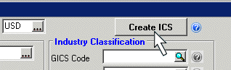

Click OK on the alert box that follows.

## ICs record layout

The ICS record contains an upper section and numerous tabs below. Most of the information in the upper section is pulled automatically from the opportunity record. Add details regarding unions, number of employees, year established and CEO, then proceed to the data tabs below.

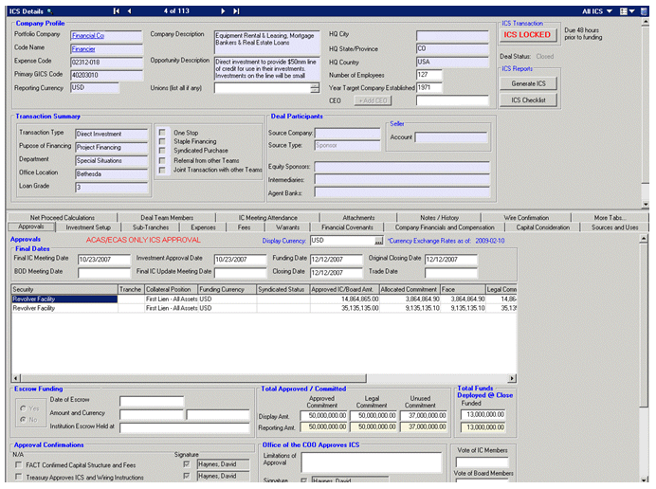

## Sequence for competing the data tabs

**Enter the Closing Date on the Approvals tab first.** This will cause fees and expenses payable at the close to tally properly in the Sources and Uses section.

The suggested sequence for posting data on the other tabs is:

• Investment Setup

• Sub-Tranches

• Fees

• Expenses

• Financial Covenants

• Company Financials and Compensation

• Capital Consideration

• Warrants

• Sources and Uses

• Attachments

## add necessary detail

### Investment Setup Tab

#### Click the investment setup tab to select it.

#### Right-click in the white space on the investment setup tab and inset a new security.

All of the information is required unless it is not applicable.

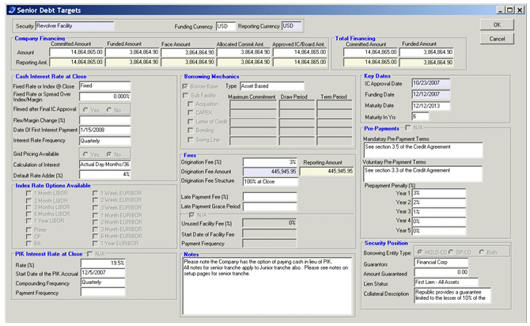

### Sub-tranches Tab

If necessary, add sub-tranches using the same process:

#### Select the sub-tranches tab

#### Click the security that will be subdivided to select it

#### Right-click in the sub-tranches section and insert a sub-tranche

Add more sub-tranches as needed

### Fees Tab

Use this tab to provide transaction fee details.

#### Select the Fees tab

#### Origination fees

Origination fees will be added automatically to the upper section of the fees tab from data posted on the investment setup tab.

#### Other fees

Structuring, management, board and other fees are added manually. Right-click in the white space in the other fees section and add details.

### Expenses Tab

Reimbursable and non-reimbursable expenses (FACT, diligence, outside legal, etc.) are added on the Expenses tab.

#### Select the Expense tab

#### Right-click the white space

#### Add expense items

Totals for reimbursable and non-reimbursable expenses are tallied below. Note that employee expense detail should be added as an attachment on the attachments tab.

### Financial Covenants tab

Covenant types and descriptions are added on this tab. The detailed covenant measurement spreadsheet is attached separately on the attachments tab.

#### Select the Covenants tab

#### Right-click the white space

#### Insert as many rows as necessary for covenant types and descriptions

### Company Financials and Compensation Tab

Historical and projected financial performance is added here, as well as cash and equity compensation for senior managers. If the senior managers are not already on file as SalesLogix contacts, add them first before completing this section. Board participation details are added on this tab too.

### Capital Considerations Tab

Clawbacks, earn-outs and other capital considerations are described here. Copy and summary text from legal documents into the sections of this tab.

### Warrants Tab

Add warrant details if applicable.

#### Select the Warrants tab

#### Click a security which has warrants

#### Provide general information, details of the warrant mechanics, put and transfer rights, etc.

### Sources and Uses Tab

#### Financing sources

Financing sources are pulled automatically from the investment setup tab

#### Additional sources

Additional sources of financing are added manually. Right-click in the white space in the additional sources section and add a description and amount.

#### Uses of financing

Major uses of financing are added manually in the Key Uses section. Right-click in the white space and add a usage item and amount. Fees and expenses are pulled automatically from their respective data tabs and are added to the key uses.

The system displays a total of sources and uses and shows a checksum indicating whether sources and uses are in balance.

### Net Proceeds Tab

The deal team will coordinate with Treasury to complete the Net proceeds tab. Begin by indicating whether this is a net funding and whether we’re invoicing for fees and expenses. In general the entity providing funding will be selected by Treasury. Fees and expenses will be pulled in automatically from their respective tabs. Wire transfer instructions are added by the deal team. Required fields are:

#### Fund

#### Currency

#### Amount

#### Date

#### Beneficiary bank

#### Beneficiary account number

#### Beneficiary account name

#### ABA number

#### Reference name and phone number

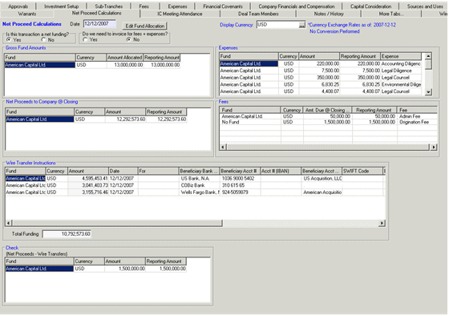

### File Attachments Tab

Several final versions of transaction documents should be attached in PDF format, including:

#### Final IC memo

#### Final financial model

#### Due diligence reports

#### E-mail approvals of changes to terms

#### Flow of funds statement

#### Financial covenant detail

#### Employee expense detail

#### Transaction tickets or trade confirmations, if applicable.

To attach documents,

#### Right-click in the white space

#### Choose ‘Insert File’

#### Browse to the location where the PDF is stored, and select it

#### If desired, add a descriptive name to the attachment

### ICS Meeting Attandance and Deal Team Members Tabs

Data on these tabs will be pulled from the opportunity record.

### Notes and History Tab

Additional notes may be added as necessary. As usual, right-click in the white space to add a note.

## Print and review the ICS

When all needed data has been entered, click the ‘Generate ICS’ button. A PDF file is created showing the ICS details. Print the file and review before submitting the ICS.

## submit the ICS

When the deal team is satisfied with the ICS, click the ‘Submit ICS’ button in the upper right. The ICS record will be locked pending review.

Typically changes are needed after the ICS is submitted. If so, comments will be added to the PDF file and it will be e-mailed back to you. The ICS record will also be unlocked. Revise the ICS record as indicated, then re-submit it.

## The deal is closed!

When the ICS record is accepted, final approvals are checked off on the Approvals tab by Treasury in conjunction with the Legal department and the wire confirmations are verified. When Legal confirms documents have been executed the ICS is locked, the opportunity is marked as closed and the record is locked, and funding takes place.